**SE3330 Course Project Iteration Planning Record**

**Iteration**: 2

**Team name**: Null Reference Exception

**Team Leader**: Liam

**Date**: 03/14/19

1. **Sprint Backlog:**

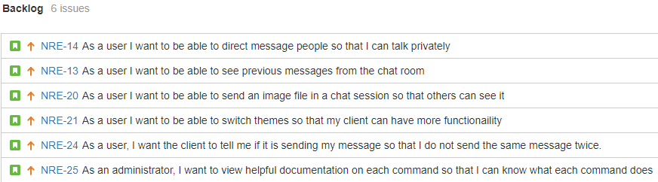

1. **Task breakdown:**

|  |  |  |  |
| --- | --- | --- | --- |
| Story ID | Tasks | Assigned to | Estimated Time |
| NRE-6 | Store procedure for obtaining usernames hashed password  **[NRE-58]** | Mitch Vance | 3 |
| Server should handle a login  **[NRE-50]** | Ryan Wolff | 2 |
| Client should handle login**[NRE-51]** | Austin Fitzgerald | 3 |
| NRE-18 | Server will send a user list to the client**[NRE-44]** | Austin Fitzgerald | 2 |
| Client will update the user list with connected users**[NRE-45]** | Ryan Wolff | 2 |
| NRE-19 | A user will be able to register for an account in the GUI**[NRE-46]** | Austin Fitzgerald | 3 |
| Design the database**[NRE-52]** | Mitch Vance | 5 |
| Connect server to database  **[NRE-53]** | Mitch Vance | 4 |
| Create the database**[NRE-54]** | Liam Crain | 4 |
| Create user and login tables  **[NRE-55]** | Liam Crain | 4 |
| Store procedure for adding user to database**[NRE-57]** | Liam Crain | 4 |
| The server should register a new user**[NRE-47]** | Ryan Wolff | 2 |
| NRE-23 | The server needs to safely shutdown **[NRE-41]** | Ryan Wolff | 5 |
| Inform client that server is shutting down **[NRE-42]** | Ryan Wolff | 1 |
| Inform the user that a message sent post-shutdown notice will not be sent **[NRE-43]** | Austin Fitzgerald | 2 |
| NRE-39 | Create a listener for shift-enter & alt-enter in the message send box **[NRE-40]** | Austin Fitzgerald | 2 |

1. **Individual Assignment Summary**

|  |  |  |
| --- | --- | --- |
| Team Member | Assigned Tasks (ID) | Total estimated time |
| Liam Crain | **[NRE-54] [NRE-55] [NRE-57]** | 12 |
| Austin Fitzgerald | **[NRE-40] [NRE-43] [NRE-44] [NRE-46] [NRE-51]** | 12 |
| Mitch Vance | **[NRE-52] [NRE-53] [NRE-58]** | 12 |
| Ryan Wolff | **[NRE-41] [NRE-42] [NRE-45] [NRE-47] [NRE-50]** | 12 |